**ASSIGNMENT 4:**

**Module 5: Files, Exceptions, and Errors in Python**

**Task 1: Read a File and Handle Errors**

**Problem Statement:** Write a Python program that:

1. Opens and reads a text file named sample.txt.

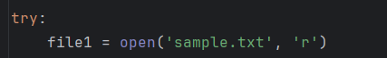

1. Prints its content line by line.

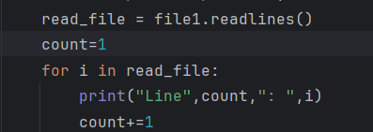

1. Handles errors gracefully if the file does not exist.

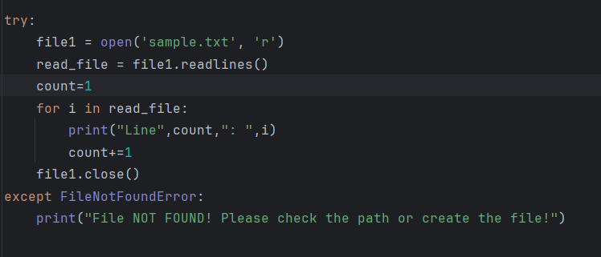

IF File Not exists:

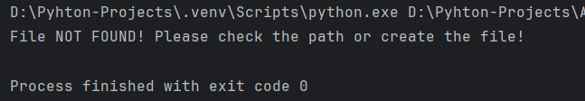

IF file exists:

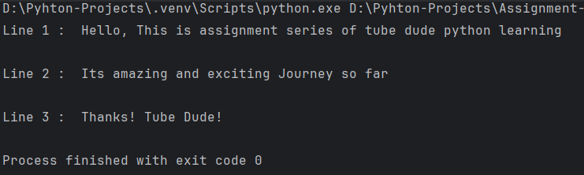

**Task 2: Write and Append Data to a File**

**Problem Statement:** Write a Python program that:

1. Takes user input and writes it to a file named **output.txt**.

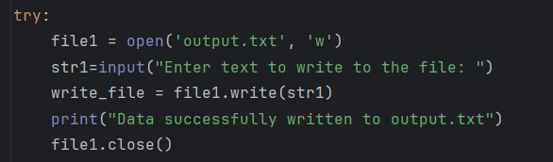

1. Appends additional data to the same file.

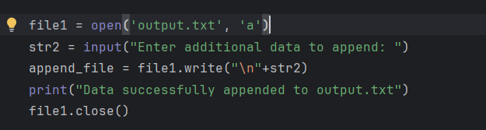

1. Reads and displays the final content of the file.

